PROGRAM 1 : PRINT HAI

SQL> set serveroutput on
SQL> begin
dbms_output.Put_line('HAI');
end;
/
OUTPUT
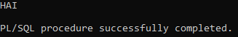

PROGRAM 2 : SUM OF TWO NUMBERS
SQL> set serveroutput on
SQL> declare
num1 number;
num2 number;
num3 number;
begin
num1:=20;
num2:=15;
num3:=num1+num2;
dbms_output.Put_line('The sum of '||num1||' and '||num2||' is '||num3);
end;
/
OUTPUT
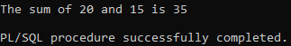

PROGRAM 3 : PRINT FIRST N PRIME NUMBERS

SQL> set serveroutput on
SQL> declare
i number(3);
j number(3);
begin
dbms_output.put_line('The prime numbers are:');
dbms_output.new_line;
i := 2;
loop
j := 2;
loop
exit when((mod(i,j)=0) or (j = i));
j := j+1;
end loop;
if(j = i) then
dbms_output.put(i||' ');
end if;
i := i+1;
exit when i = 50;
end loop;
dbms_output.new_line;
end;
/
OUTPUT
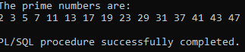
PROGRAM 4 : FACTORIAL OF A NUMBER:

SQL> set serveroutput on
SQL> declare
num number := 6;
fact number := 1;
temp number;
begin
temp := num;
while(temp>0)
loop
fact := fact*temp;
temp := temp-1;
end loop;
dbms_output.put_line('factorial of'||num||' is' ||fact);
end;
/
OUTPUT
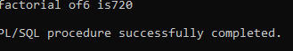
PROGRAM 5 :FACTORIAL OF ANY NUMBER

SQL> set serveroutput on
SQL> declare
fac number :=1;
n number := &1;
begin
while n>0
loop
fac := n*fac;
n :=n-1;
end loop;
dbms_output.put_line(fac);
end;
/
OUTPUT
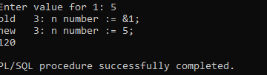
PROGRAM 6 : ADDITION OF A NUMBER

SQL> declare
x number(5);
y number(5);
z number(7);
begin
x := 10;
y := 20;
z := x+y;
dbms_output.put_line('Sum is'||z);
end;
/
OUTPUT
